A

Mini Project On

#### USED CAR’s PRICE PREDICTION

**USING MACHINE LEARNING WITH PYTHON**

#### (Submitted in partial fulfillment of the requirement for the award of Degree) of

**BACHELOR OF TECHNOLOGY**

#### In

**COMPUTER SCIENCE AND ENGINEERING SUBMITTED BY**

#### G. SHRIYA

**P. DIVYA**

#### V. VANI

- **197R1A0576**

#### - 197R1A0597

- **197R1A05B4**

#### Under the Guidance Of

**V NARESH KUMAR**

## (Assistant Professor)



#### DEPARTMENT OF COMPUTER SCIENCE AND ENGINEERING CMR TECHNICAL CAMPUS

**UGC AUTONOMOUS**

**(Accredited by NAAC, NBA, Permanently Affiliated to JNTUH, Approved by AICTE, New Delhi Recognized Under Section 2(f) & 12(B) of the UGCAct.1956, Kandlakoya(V) Medchal Road, Hyderabad- 501401.**

**DEPARTMENT OF COMPUTER SCIENCE AND ENGINEERING**



## CERTIFICATE

This is to certify that the project entitled as “**USED CAR’s PRICE PREDICTION USING MACHINE LEARNING WITH PYTHON”** is submitted by **G. SHRIYA**

**(197R1A0576), P. DIVYA (197R1A097), V. VANI (197R1A05B4)** in partial fulfillment of the requirements for the award of the degree of B. Tech in Computer Science and Engineering to the Jawaharlal Nehru Technological University Hyderabad, is a record of bonafide work carried out by him/her under our guidance and supervision during the year 2022 – 2023.

The results embodied in this thesis have not been submitted to any other University or Institute for the award of any degree or diploma.

#### V.NARESH KUMAR Dr. A. Raji Reddy

**Assistant Professor INTERNAL GUIDE**

#### DIRECTOR

**Dr. K. SRUJAN RAJU HOD**

#### EXTERNAL EXAMINER

**Submitted for viva Examination held on**

**ACKNOWLEDGEMENT**

Apart from the efforts of us, the success of any project depends largely on the encouragement and guidelines of many others. We take this opportunity to express our gratitude to the people who have been instrumental in the successful completion of this project.

We take this opportunity to express my deep gratitude and regard to my guide **Mr. V. Naresh Kumar**, Assistant Professor for his exemplary guidance, monitoring and constant encouragement throughout the project work. The blessing, help and guidance given by him shall carry us a long way in the journey of life on which we are about to embark.

We also take this opportunity to express a deep sense of gratitude to Project Review Committee (PRC) **Dr. Punyaban Patel, Ms. Shilpa, Mr. G. Vijay Kumar, Dr. M. Subha Mastan Rao & J. Narasimha Rao** for their cordial support, valuable information and guidance, which helped us in completing this task through various stages.

We are also thankful to **Dr. K. Srujan Raju**, Head of the Department of Computer Science and Engineering for providing encouragement and support for completing this project successfully.

We are obliged to **Dr. A. Raji Reddy**, Director for being cooperative throughout the course of this project. We also express our sincere gratitude to **Sri. Ch. Gopal Reddy**, Chairman for providing excellent infrastructure and a nice atmosphere throughout the course of this project.

The guidance and support received from all the members of **CMR Technical Campus** who contributed to the completion of the project. We are grateful for their constant support and help.

Finally, we would like to take this opportunity to thank our family for their constant encouragement, without which this assignment would not be completed. We sincerely acknowledge and thank all those who gave support directly and indirectly in the completion of this project.

**G Shriya (197R1A0576) P Divya (197R1A0597) V Vani (197R1A05B4)**

**ABSTRACT**

In this project, I investigate the application of supervised machine learning techniques to predict the price of used cars in India. The predictions are based on historical data collected from CarDheko website. Different techniques like multiple linear regression analysis, random forest and decision trees have been used to make the predictions. We use Regressor’s to estimate the selling price of the car. The drawback of using cluster is due to providence of Boolean, Yes/No types etc. The predictions are then evaluated and compared in order to find those which provide the best performances. A seemingly easy problem turned out to be indeed very difficult to resolve with high accuracy. All the three methods provided comparable performance. In the future, we intend to use more sophisticated algorithms to make the predictions.

Determining whether the listed price of a used car is a challenging task, due to the many factors that drive a used vehicle’s price on the market. The focus of this project is developing machine learning models that can predict the preliminary maximum price of a used car based on its features, in order to make informed purchases. We implement and evaluate various learning methods on a dataset consisting of the sale prices of different models. Conventional linear regression also yielded satisfactory results, with the advantage of a significantly lower training time in comparison to the aforementioned methods.

### LIST OF FIGURES/TABLES

**FIGURE NO FIGURE NAME PAGE NO**

|  |  |  |
| --- | --- | --- |
| **FIGURE 3.1** | **PROJECT ARCHITECTURE** | **6** |
| **FIGURE 3.2** | **USE CASE DIAGRAM** | **7** |
| **FIGURE 3.3** | **CLASS DIAGRAM** | **8** |
| **FIGURE 3.4** | **SEQUENCE DIAGRAM** | **9** |
| **FIGURE 3.5** | **ACTIVITY DIAGRAM** | **10** |

### LIST OF SCREENSHOTS

|  |  |  |
| --- | --- | --- |
| **SCREENSHOT NO.** | **SCREENSHOT NAME** | **PAGE NO.** |
| **5.1** | **COLLECTING DETAILS OF VARIOUS CARS** | **13** |
| **5.1.2** | **ORGINAL AND PREDICTED VALUES SHOWN WHEN**  **LINEAR REGRESSION ALGORITHM APPLIED** | **17** |
| **5.1.3** | **ORGINAL AND PREDICTED VALUES SHOWN WHEN**  **DECISION TREE ALGORITHM APPLIED** | **17** |
| **5.1.4** | **ORGINAL AND PREDICTED VALUES SHOWN WHEN RANDOM FOREST ALGORITHM APPLIED** | **18** |
| **6.1** | **INDEX PAGE** | **19** |
| **6.2** | **SIGNUP PAGE** | **20** |
| **6.3** | **LOGIN PAGE** | **20** |
| **6.4** | **WELCOME PAGE** | **21** |
| **6.5** | **FORM PAGE** | **21** |
|  | **iii** |  |

**TABLE OF CONTENTS**







### INTRODUCTION

* 1. **PROJECT SCOPE**

### PROJECT PURPOSE

* 1. **PROJECT FEATURES**

### SYSTEM ANALYSIS

* 1. **PROGRAM DEFINITION**

### EXISTING SYSTEM

* + 1. **DISADVANTAGES OF EXISTING SYSTEM**

### PROPOSED SYSTEM

* + 1. **ADVANTAGES OF PROPOSED SYSTEM**

### FEASIBILITY

* + 1. **ECONOMIC FEASIBILITY**

### TECHNICAL FEASIBILITY

* + 1. **BEHAVIOURAL FEASIBILITY**

### HARDWARE AND SOFTWARE REQUIREMENTS

1. **ARCHITECTURE**

### PROJECT ARCHITECTURE

* 1. **USE CASE DIAGRAM**

### CLASS DIAGRAM

* 1. **SEQUENCE DIAGRAM**

### ACTIVITY DIAGRAM

1. **MODULES**

### i ii iii

**1**

### 1

**1**

### 1

**2**

### 2

**2**

### 3

**3**

### 3

**3**

### 4

**4**

### 4

**5**

### 6

**6**

### 7

**8**

### 9

**10**

**11**

1. IMPLEMENTATION 12
   1. SAMPLE CODE 14
2. RESULTS 19
3. TESTING 22

INTRODUCTION TO TESTING 22

* 1. TYPES OF TESTING 22
     1. UNIT TESTING 22
     2. INTEGRATED TESTING 22
     3. FUNCTIONAL TESTING 23
  2. TEST CASES 23
     1. CLASSIFICATION 23

1. CONCLUSION 24
   1. CONCLUSION 24
   2. FUTURE SCOPE 24
2. REFERERNCES 25
   1. REFERERNCES 25
   2. BIBLIOLOGY 25

# INTRODUCTION

## INTRODUCTION

### PROJECT SCOPE

This project is titled as “Used Car‟s Price Prediction using Machine Learning with python”. The main objective is to build a supervised machine learning model for Forecasting value of a vehicle based on multiple attributes. The system that is being built must be future based that i.e future wise prediction must be possible. Providing graphical comparisons to provide a better view.

### PROJECT PURPOSE

The main goal of the project is to identify the accurate price of the Used car using machine learning algorithm. So, the user will be able to compare the price of the different cars he wants to buy and selects a car according to his budget. The dataset is collected from the Car Dekho website.

### PROJECT FEATURES

Accurate car price prediction involves expert knowledge, because price usually depends on many unique features and factors. Generally, most important ones are brand name and model, years, KMs driven and mileage. The fuel type used in the car as well as fuel consumption per mile highly affected price of a car due to often changes in the price of a fuel. Distinct features like exterior color, door number, type of transmission, dimensions, safety, air condition, interior, whether it has navigation or not will also results in the car price.

CMRTC 1

# SYSTEM ANALYSIS

### SYSTEM ANALYSIS

System analysis is the important phase in this process. The System is studied to the minute details and analyzed. The system analyst plays an important role of an interrogator and dwells deep into the working of the present system. In analysis, a detailed study of these operations performed by the system and their relationships within and outside the system is done. A key question considered here is, “what must be done to solve the problem?” The system is viewed as a whole and the inputs to the system are identified. Once analysis is completed the analyst has a firm understanding of what is to be done.

### PROBLEM DEFINITION

The prices of new cars in the industry is fixed by the manufacturer with some additional costs incurred by the Government in the form of taxes. So, customers buying a new car can be assured of the money they invest to be worthy. But due to the increased price of new cars and the incapability of customers to buy new cars due to the lack of funds, used cars sales are on a global increase. There is a need for a used car price prediction system to effectively determine the worthiness of the car using a variety of features. Even though there are websites that offers this service, their prediction method may not be the best. Besides, different models and systems may contribute on predicting power for a used car‟s actual market value. It is important to know their actual market value while both buying and selling.

### EXISTING SYSTEM

The prices of new cars in the industry is fixed by the manufacturer with some additional costs incurred by the Government in the form of taxes. So, customers buying a new car can be assured of the money they invest to be worthy. But due to the increased price of new cars and the incapability of customers to buy new cars due to the lack of funds, used cars sales are on a global increase. There is a need for a used car price prediction system to effectively determine the worthiness of the car using a variety of features. Even though there are websites that offers this service, their prediction method may not be the best. Besides, different models and systems may contribute on predicting power for a used car‟s actual market value. It is important to know their actual market value while both buying and selling.

### DISADVANTAGES OF EXISTING SYSTEM

* + - * Old Technology
      * Early – Onset Problems
      * High Maintenance
      * Often „”NO‟‟ Warranty
      * Used cars are less reliable

### PROPOSED SYSTEM

Deciding whether a used car is worth the posted price when you see listings online can be difficult. Several factors, including mileage, make, model, year, etc. can influence the actual worth of a car. From the perspective of a seller, it is also a dilemma to price a used car appropriately. Based on existing data, the aim is to use machine learning algorithms to develop models for predicting used car prices.

### ADVANTAGES OF PROPOSED SYSTEM

* Affordable Prices
* Low Depreciation Rates
* Lower Insurance Rates
* Fewer Sales Tax
* Cheaper Repairs

### FEASIBILITY STUDY

The feasibility of the project is analyzed in this phase and business proposal is put forth with a very general plan for the project and some cost estimates. During system analysis the feasibility study of the proposed system is to be carried out. This is to ensure that the proposed system is not a burden to the company. Three key considerations involved in the feasibility analysis are Economic, Technical and social Feasibility

### ECONOMIC FEASIBILITY

This study is carried out to check the economic impact that the system will have on the organization. The amount of fund that the company can pour into the research and development of the system is limited. The expenditures must be justified. Thus the developed system as well within the budget and this was achieved because most of the technologies used are freely available. Only the customized products had to be purchase

### TECHNICAL FEASIBILITY

This study is carried out to check the technical feasibility, that is, the technical requirements of the system. Any system developed must not have a high demand on the available technical resource s. This will lead to high demands on the available technical resources. This will lead to high demands being placed on the client. The developed system must have a modest requirement, as only minimal or null changes are required for implementing this system.

### BEHAVIOURAL FESAIBILITY

The aspect of study is to check the level of acceptance of the system by the user. This includes the process of training the user to use the system efficiently. The user must not feel threatened by the system, instead must accept it as a necessity. The level of acceptance by the users solely depends on the methods that are employed to educate the user about the system and to make him familiar with it. His level of confidence must be raised so that he is a lso able to make some constructive criticism, which is welcomed, as he is the final user of the system.

### HARDWARE & SOFTWARE REQUIREMENTS

* + 1. **HARDWARE REQUIREMENTS:**

Hardware interfaces specifies the logical characteristics of each interface between the software product and the hardware components of the system. The following are hardware requirements.

* Processor : Pentium IV or higher
* RAM : 4 GB or More
* Space on Hard Disk : 128 GB or More

### SOFTWARE REQUIREMENTS:

Software Requirements specifies the logical characteristics of each interface and software components of the system. The following are some software requirements.

* Operating System : Windows 7 or Later
* Coding Language : Python
* Editor : Colabs

# ARCHITECTURE

### ARCHITECTURE

* 1. **PROJECT ARCHITECTURE**

This project architecture shows the procedure followed for classification, starting from input to final prediction.

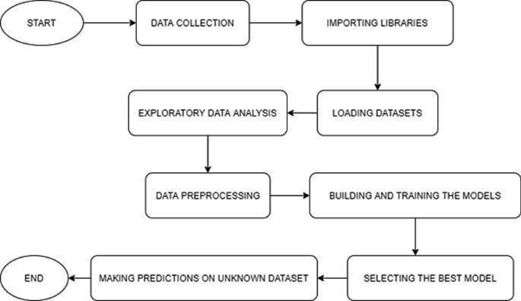

**Fig 3.1:Project architecture of Used car’s Price Prediction Using Machine with python**

### USE CASE DIAGRAM

In the Use Case diagram, we have basically one actor who is the user in the trained

model.

A Use Case diagram is a graphical depiction of a user’s possible interactions with a system. A use case diagram shows various Use Case’s and different types of user’s the system has. The Use Case’s are represented by either circles or ellipses. The actor are often shown as stick figures.

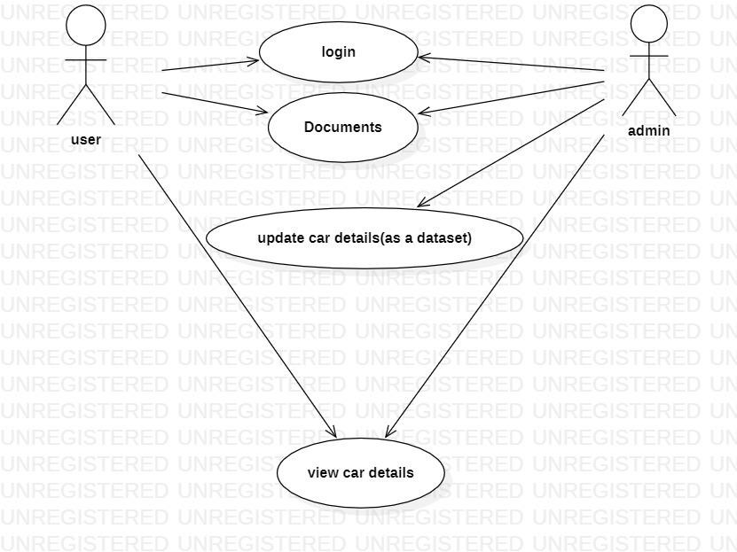

**Fig 3.2:Use Case diagram for Used car’s Price Prediction Using Machine with python**

### CLASS DIAGRAM

Class diagram is a type of static structure diagram that describes the structure of a system by showing the systems classes ,their attributes, operations(Methods),and their relationships among objects.

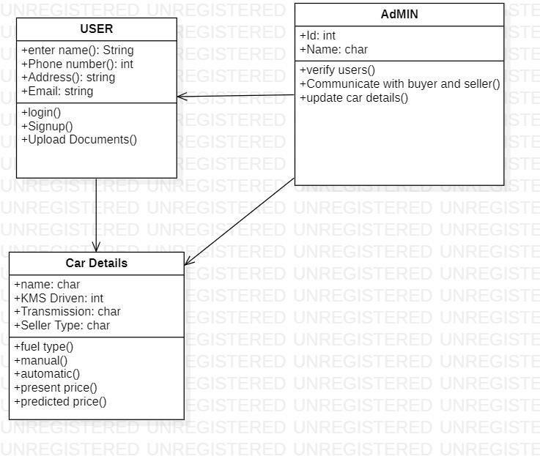

**Fig 3.3:Class diagram for Used car’s Price Prediction Using Machine with python**

### SEQUENCE DIAGRAM

A Sequence diagram shows object interactions arranged in time sequence .It depicts the objects involved in the scenario and the sequence of messages exchanged between the objects needed to carry out the functionality of the scenario. Sequence diagrams are typically associated with Use Case realizations in the logical view of the system under development.

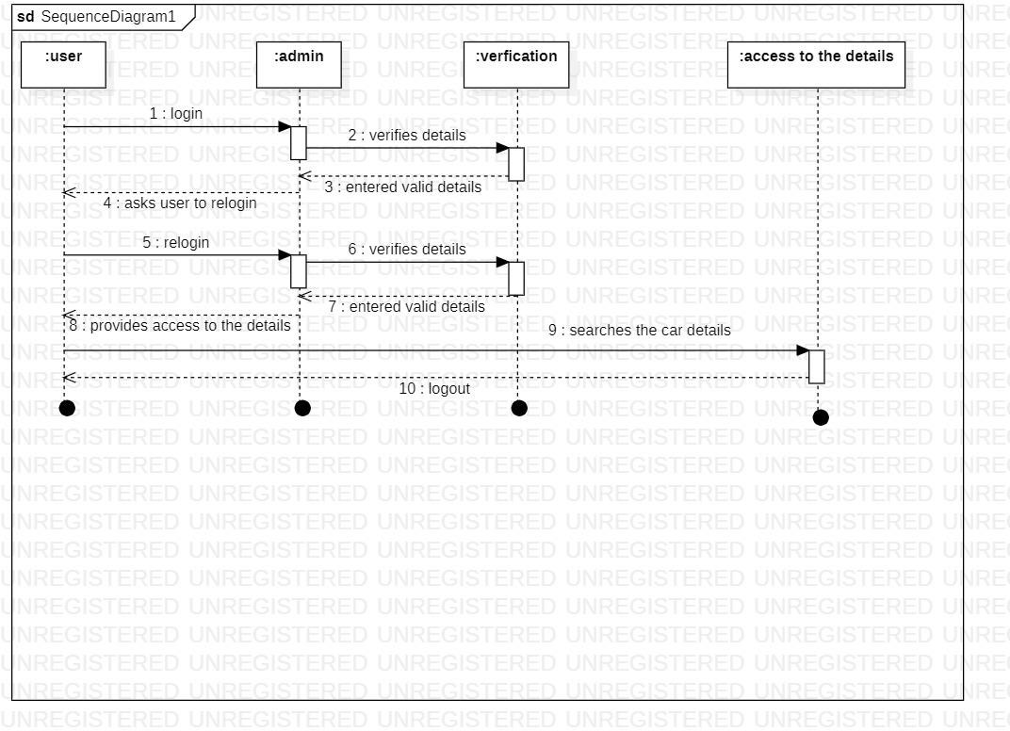

**Fig 3.4:Sequence diagram for Used car’s Price Prediction Using Machine with python**

### ACTIVITY DIAGRAM

Activity diagram are graphical representations of work flows of step wise activities and actions with support for choice, iteration and, concurrency. They can also include elements showing the flow of data between activities through one or more data stores.

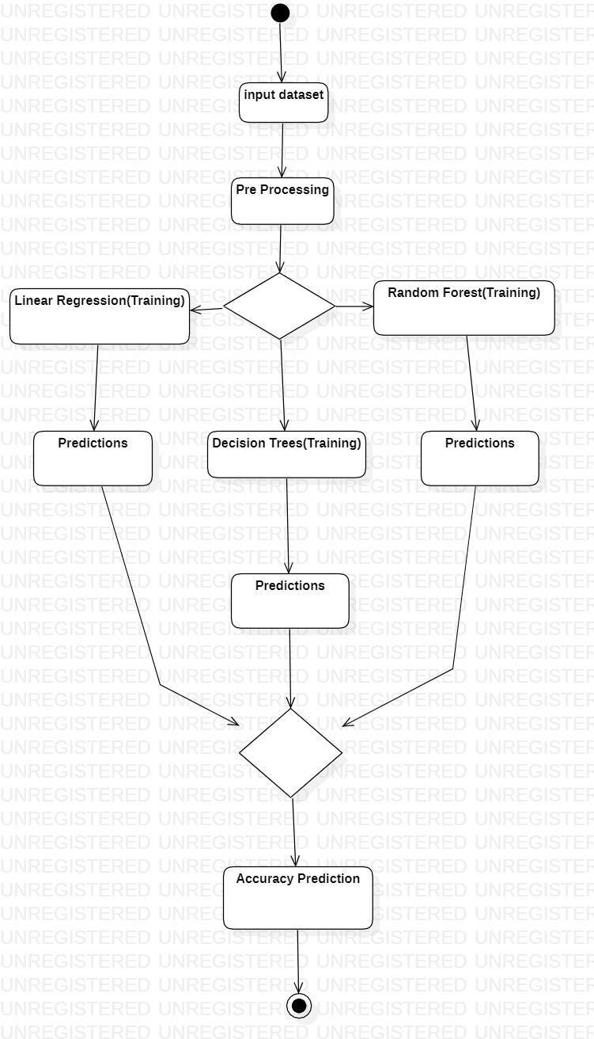

**Fig 3.5:Activity diagram for Used car’s Price Prediction Using Machine with python**

# MODULES

USED CAR’S PRICE PREDICTION USING MACHINE LEARNING WITH PYTHON

### MODULES

**TYPES OF LOGIN:** USER, ADMIN

**USER SIGNUP:** If the user is visiting the web page for the first time, they has to enter the details such as email I’d, phone number and create a password.

**USER LOGIN:** if the user existing then they have to enter their email and password.

**ADMIN:** Admin verifies the details of the user; if user provides with the valid credentials then admin provides the access to the details of the car’s, else the admin will ask the user to re-login with the valid credentials

# IMPLEMENTATION

**Machine Learning Libraries used in this Project:**

**Pandas:**

A Panda is a Python package providing fast, flexible, and expressive data structures designed to make working with relational or labeled data both easy and intuitive. It aims to be the fundamental high-level building block for doing practical, real world data analysis in Python.

**Numpy:**

Numpy brings the computational power of languages like C and Fortran to Python, a language much easier to learn and use. With this power comes simplicity: a solution in Numpy is often clear and elegant. Numpy is a python library used for working with arrays. It also has functions for working in domain of linear algebra, fourier transform, and matrices. Numpy was created in 2005 by Travis Oliphant. It is an open source project and you can use it freely. Numpy stands for Numerical Python.

**Matplotlib:**

Matplotlib is a comprehensive library for creating static, animated, and interactive visualizations in Python. Matplotlib makes easy things easy and hard things possible. Matplotlib is the brainchild of John Hunter (1968-2012), who, along with its many contributors, have put an immeasurable amount of time and effort into producing a piece of software utilized by thousands of scientists worldwide.

**Sea born:**

Seaborn is a Python data visualization library based on matplotlib. It provides a high- level interface for drawing attractive and informative statistical graphics. It will be used to visualize random distributions.

**DATA COLLECTION**

The data-set used in this project was downloaded from Kaggle. It was uploaded by CarDekho company whose job is to buy and sell used cars in India. It contains most all relevant information about car sales including columns like car name, year, selling price, present price, kms driven, fuel type, seller type, transmission, owner.

* Car_Name :- Name of the car.
* Year :-Year of Purchase of the specified car.
* Selling_Price :-Selling price of that car.
* Present_Price :- Actual price of the car purchased.
* Kms_Driven :- Number of KMs driven shown in odometer.
* Fuel_Type :- fuel type (Petrol or Diesel or CNG).
* Seller_Type :- Either the seller is Dealer or Individual.
* Transmission :-Tells the vehicle transmission is Manual or Automatic.
* Owner :- Tells either the owner is 1st owner or not.

**Here is the sample CSV file of the Used Cars:**

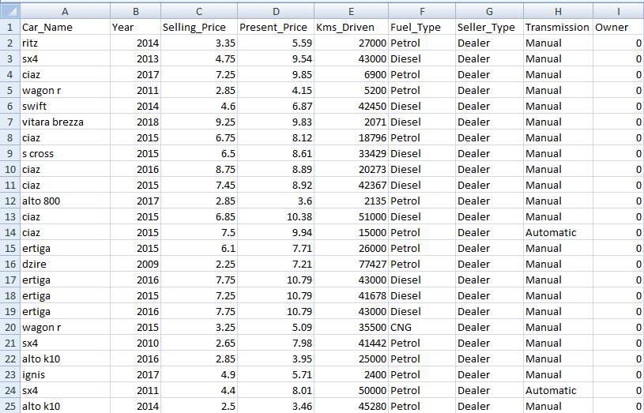[https://drive.google.com/file/d/1u04Ll9FnDx2vHyQ7CPQR8l6M_-2-r0-0/view?usp+share_link](https://drive.google.com/file/d/1u04Ll9FnDx2vHyQ7CPQR8l6M_-2-r0-0/view?usp%2Bshare_link)

**Fig 5.1:Collecting data of various types of cars**

### 5.1 SAMPLE CODE

#### Loading Data and Explanation of Features

import numpy as np import pandas as pd import seaborn as sns

import matplotlib.pyplot as plt import warnings warnings.filterwarnings("ignore")

#### #reads the data and prints the first five rows from the csv file using head() function

data=pd.read_csv("carsdata.csv") data.head()

#### #gives information about each and every column

data.info()

#### #shows whether the any of columns have null value or not

data.isna().any()

1. **#Prints no.of cars based on fuel type, Seller type and Transmission** print(data.Fuel_Type.value_counts(),"\n") print(data.Seller_Type.value_counts(),"\n")

print(data.Transmission.value_counts())

#### #assigning the value for different types of car as shown below

#Fuel_Type ==> 1 = Petrol , 0 = Diesel , 2 = CNG #Transmission_Type ==> 1 = Manual , 0 = Automatic #Seller_Type ==> 1 = Dealer , 0 = Individual

data.Fuel_Type.replace(regex={"Petrol":"0","Diesel":"1","CNG":"2"},inplace=True) data.Seller_Type.replace(regex={"Dealer":"0","Individual":"1"},inplace=True) data.Transmission.replace(regex={"Manual":"0","Automatic":"1"},inplace=True)

data[["Fuel_Type","Seller_Type","Transmission"]]=data[["Fuel_Type","Seller_Type","Trans mission"]].astype(int)

### 1...EXPLORATORY DATA ANALYSIS (EDA)

**#Prints the plot of every column by using seaborn which is for data visualization** sns.pairplot(data,diag_kind="kde", diag_kws=dict(shade=True, bw=.05, vertical=False)) plt.show()

**#This provides some basic 3D plotting tools.** from mpl_toolkits.mplot3d import Axes3D fig = plt.figure(figsize=(16,9))

ax = fig.gca(projection = "3d") plot = ax.scatter(data["Year"], data["Present_Price“ data["Kms_Driven"], linewidth=1,edgecolor ="k",

c=data["Selling_Price"],s=100,cmap="hot") ax.set_xlabel("Year") ax.set_ylabel("Present_Price") ax.set_zlabel("Kms_Driven")

lab = fig.colorbar(plot,shrink=.5,aspect=5) lab.set_label("Selling_Price",fontsize = 15)

plt.title("3D plot for Year, Present price and Kms driven",color="red") plt.show()

1. **APPLYING REGRESSION MODELS** y=data.Selling_Price x=data.drop(["Selling_Price","Car_Name"],axis=1) **#assigning selling price to y variable**

#### #dropping selling price in x variable since it is assigned to y #Dropping car name as it is not necessary

**#here starts the training of the model by using sklearn (sci-kit learn)**

from sklearn.model_selection import train_test_split x_train,x_test,y_train,y_test=train_test_split(x,y,test_size=0.2,random_state=1) print("x train: ",x_train.shape)

print("x test: ",x_test.shape) print("y train: ",y_train.shape) print("y test: ",y_test.shape)

#### #The metrics is used for the evaluation of score by using various regression models

from sklearn.metrics import r2_score

from sklearn.model_selection import cross_val_score cv=5

r_2=[]

CV=[]

#### # Main function for models

def model(algorithm,x_train_,y_train_,x_test_,y_test_): algorithm.fit(x_train_,y_train_) predicts=algorithm.predict(x_test_) prediction=pd.DataFrame(predicts) R_2=r2_score(y_test_,prediction) cross_val=cross_val_score(algorithm,x_train_,y_train_,cv=cv)

**# Appending results to Lists** r_2.append(R_2) CV.append(cross_val.mean()) **# Printing results** print(algorithm,"\n") print("r_2 score :",R_2,"\n")

print("CV scores:",cross_val,"\n") print("CV scores mean:",cross_val.mean())

**# Plot for prediction vs originals** test_index=y_test_.reset_index()["Selling_Price"] ax=test_index.plot(label="originals",figsize=(12,6),linewidth=2,color="r") ax=prediction[0].plot(label = "predictions",figsize=(12,6),linewidth=2,color="g") plt.legend(loc='upper right')

plt.title("ORIGINALS VS PREDICTIONS")

plt.xlabel("index") plt.ylabel("values") plt.show()

### LINEAR REGRESSION

from sklearn.linear_model import LinearRegression lr = LinearRegression() model(lr,x_train,y_train,x_test,y_test)

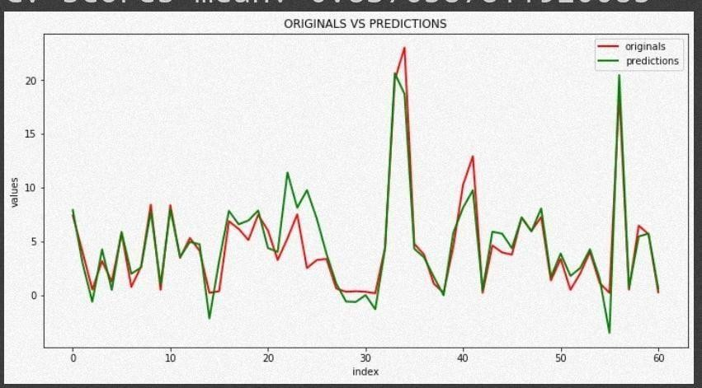

**Fig 5.1.2:Orginal and predicted values shown when linear Regression algorithm applied**

### DECISION TREE

from sklearn.tree import DecisionTreeRegressor dtr = DecisionTreeRegressor() model(dtr,x_train,y_train,x_test,y_test)

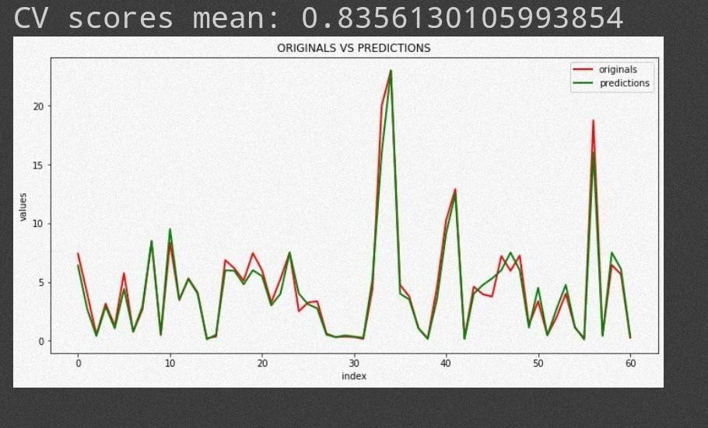

**Fig:5.1.3:Orginal and predicted values shown when Decision Tree algorithm applied**

### RANDOM FOREST

from sklearn.ensemble import RandomForestRegressor

rf = RandomForestRegressor(n_estimators = 100, random_state = 42) model(rf,x_train,y_train,x_test,y_test)

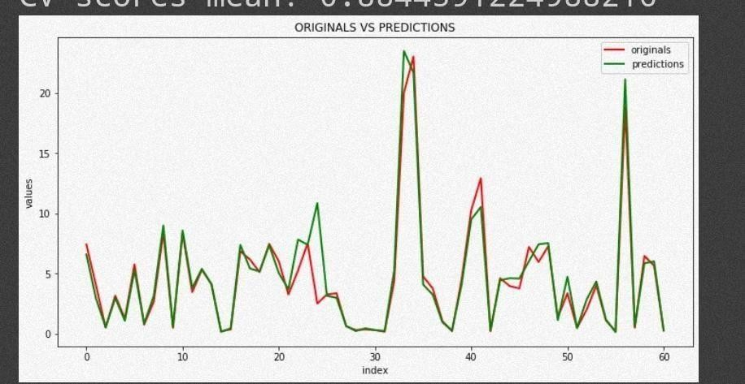

**Fig:5.1.4:Orginal and predicted values shown when Random Forest algorithm applied**

# RESULTS

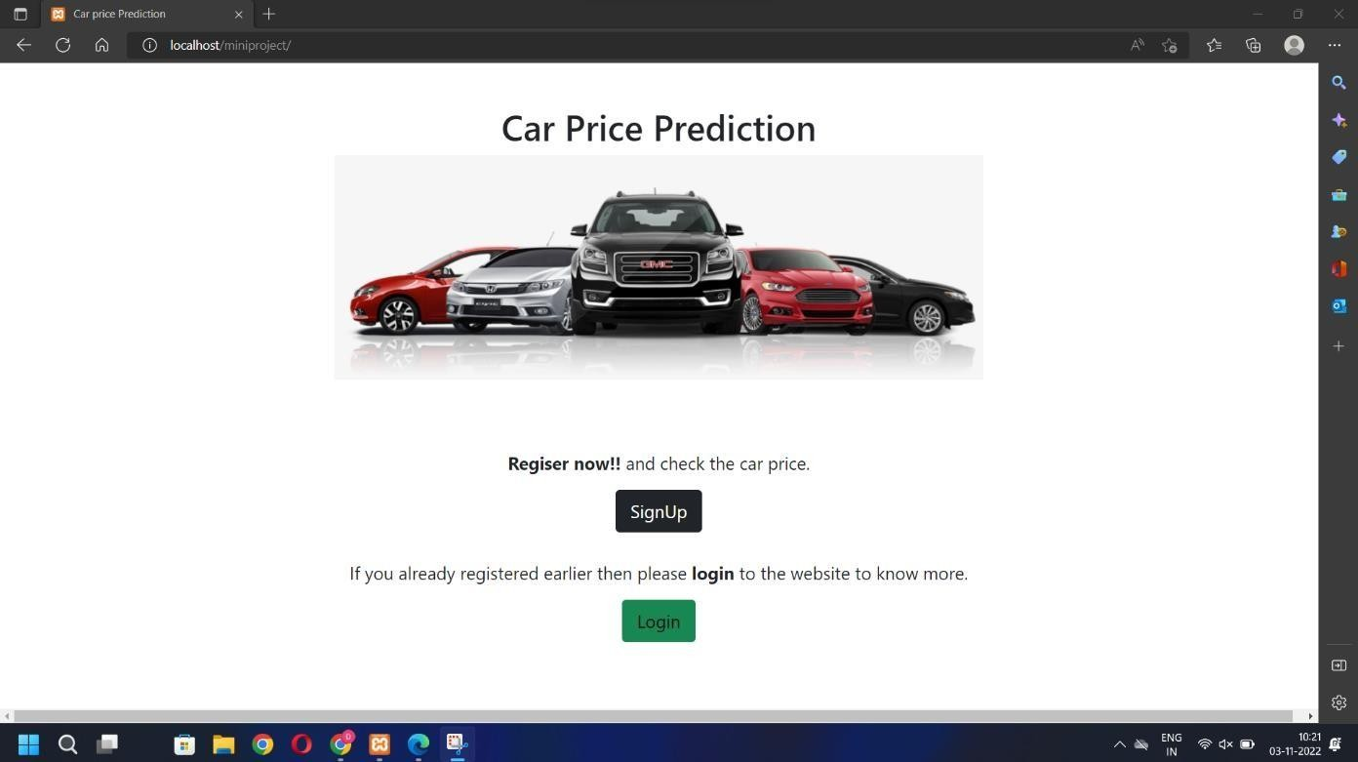

**Screenshot 6.1:Index page**

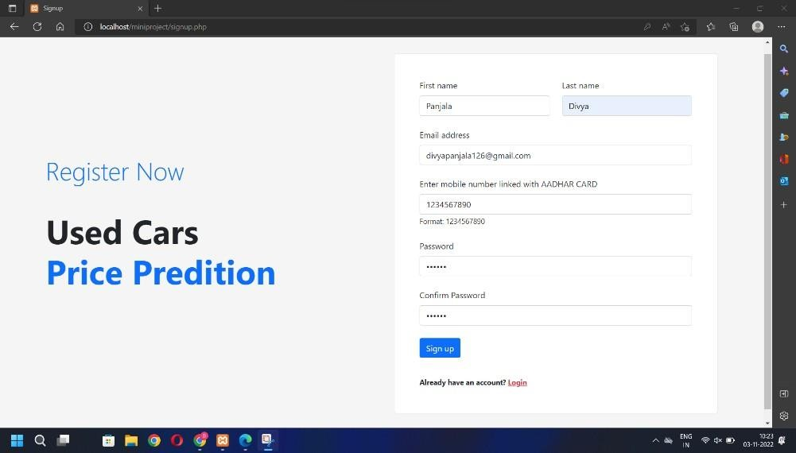

**Screenshot 6.2: Sign Up Page**

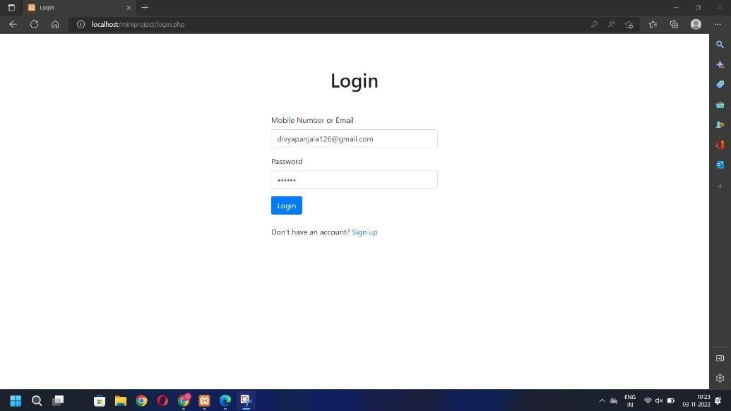

**Screenshot 6.3:Login page**

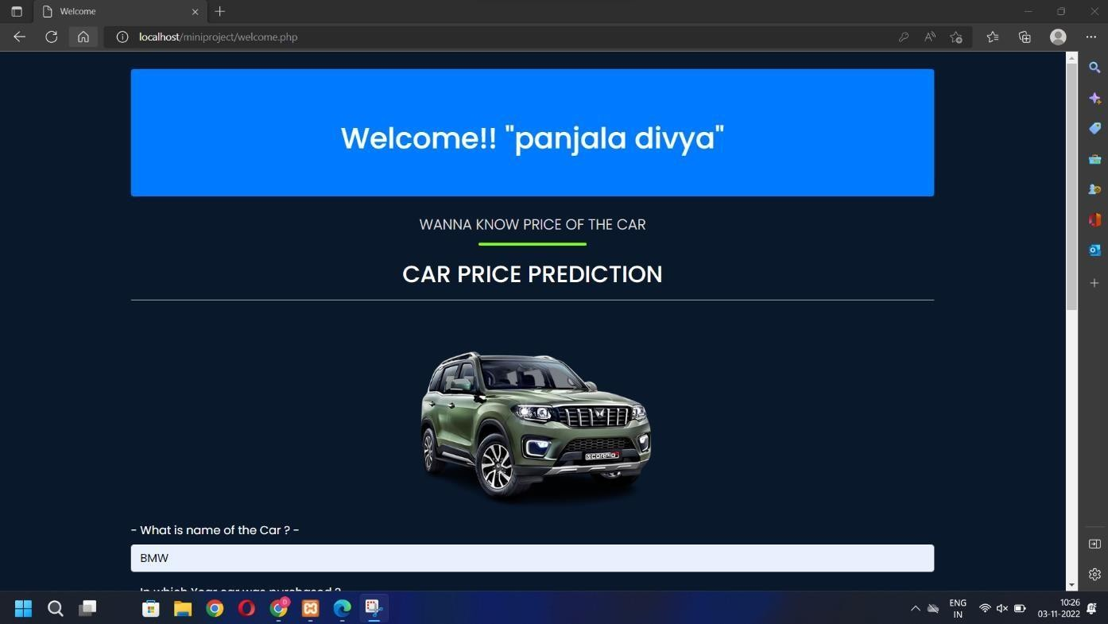

**Screenshot 6.4:Welcome Page**

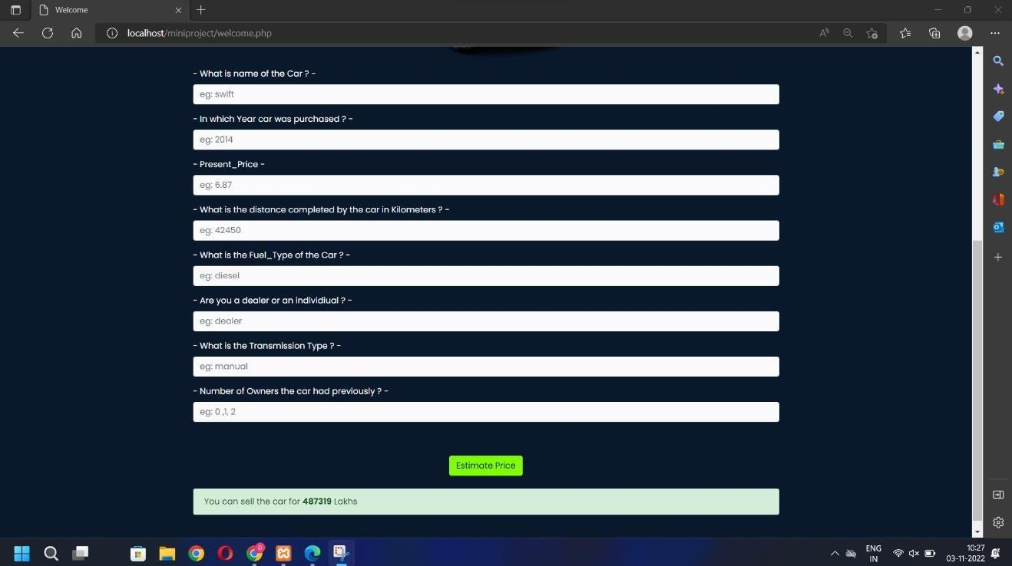

**Screenshot 6.5:Form Page**

# TESTING

### TESTING

### INTRODUCTION TO TESTING

An estimate says that 50% of whole software development process should be tested.The errors that are occurred may destroy the entire software. Software testing isdone while coding by the developers and through testing is conducted by testing experts at various level of code such as module testing, program testing, in-house testing and testing the product at user‟s end. Early discovery of errors and their remedy is the key to reliable software.

### TYPES OF TESTING

### UNIT TESTING

Unit testing involves the design of test cases that validate that the internal program logic is functioning properly, and that program inputs produce valid outputs. All decision branches and internal code flow should be validated. It is the testing of individual software units of the application .it is done after the completion of an individual unit before integration. This is a structural testing, that relies on knowledge of its construction and is invasive. Unit tests perform basic tests at component level and test a specific business process, application, and/or system configuration. Unit tests ensure that each unique path of a business process performs accurately to the documented specifications and contains clearly defined inputs and expected results.

### INTEGRATION TESTING

Integration tests are designed to test integrated software components to determine if they actually run as one program. Testing is event driven and is more concerned with the basic outcome of screens or fields. Integration tests demonstrate that although the components were individually satisfaction, as shown by successfully unit testing, the combination of components is correct and consistent. Integration testing is specifically aimed at exposing the problems that arise from the combination of components.

### FUNCTIONAL TESTING

Functional tests provide systematic demonstrations that functions tested are available as specified by the business and technical requirements, system documentation, and user manuals.

Functional testing is centered on the following items:

Valid Input : identified classes of valid input must be accepted

Invalid Input : identified classes of invalid input mustbe rejected Functions : identified functions must be exercised.

Output : identified classes of application outputs must be exercised. Systems/Procedures : interfacing systems or procedures must be invoked.

Organization and preparation of functional tests is focused on requirements, keyfunctions, or special test cases.

### TEST CASES

### 7.2.1 CLASSIFICATION

|  |  |  |  |  |
| --- | --- | --- | --- | --- |
| **TEST ID** | **TESTCASE NAME** | **PURPOSE** | **INPUT** | **OUTPUT** |
| 1 | LOGIN | TO ACCESS THE DETAILS | ENTERS VALID DETILS | ALLOWS TO ACCESS |
| 2 | LOGIN | TO ACCESS THE DETAILS | ENTERS VALID DETILS | DECLINES THE ACCESS |

# CONCLUSION

* 1. **CONCLUSION:**

By performing different models, it was aimed to get different perspectives and eventually compared their performance. With this study, it purpose was to predict prices of used carsby using a dataset. With the help of the data visualizations and exploratory data analysis, the dataset was uncovered and features were explored deeply. The relation between features were examined. At the last stage, predictive models were applied to predict priceof cars in an order: linear regression, Decision trees, Random forest.

By considering all 3 metrics, it can be concluded that random forest the bestmodel for the prediction for used car prices. Random Forest as a regression model gave the best values.

* 1. **FUTURESCOPE:**

The potential idea behind the project is the additional feature of various Machine Learning algorithms. The future enhancement would be securing the data by asking user to enter their original and certified id by the government so, that the data cannot be stolen or hacked by others.

# REFERENCES

USED CAR‟S PREDICTION USING MACHINE LEARNING WITH PYTHON

### REFERENCES:

* + 1. <https://www.wired.co.uk/topic/artificial-intelligence>
    2. <https://medium.com/machine-learning-for-all>
    3. <https://www.coursera.org/learn/uol-machine-learning-for-all>
    4. <https://www.techrepublic.com/article/machine-learning-the-smart-persons-guide/>
    5. <https://www.ijeat.org/wp-content/uploads/papers/v9i1s3/A10421291S319.pdf>
    6. [https://medium.com/analytics-vidhya/used-cars-price-estimation-a-regression-model-](https://medium.com/analytics-vidhya/used-cars-price-estimation-a-regression-model-f91d9c26d102) [f91d9c26d102](https://medium.com/analytics-vidhya/used-cars-price-estimation-a-regression-model-f91d9c26d102)

### GITHUB LINK

[shriya0201/Used-Car-s-Price-Prediction-Using-Machine-Learning-With-Python (github.com)](https://github.com/shriya0201/Used-Car-s-Price-Prediction-Using-Machine-Learning-With-Python)

### BOOK REFERENCES

1. Baldi, P. and Brunak, S. (2002). Bioinformatics: A Machine Learning Approach.
2. Baldi, P., Frasconi, P., Smyth, P. (2003). Modeling the Internet and the Web - Probabilistic Methods and Algorithms.
3. Bishop, C. M. Neural Networks for Pattern Recognition. New York: Oxford University Press (1995).
4. Cristianini, N. and Shawe-Taylor, J. (2000). An Introduction to Support Vector Machines. London: Cambridge University Press.
5. Duda, R., Hart, P., and Stork, D. (2001). Pattern Classification. New York: Wiley.
6. Hastie, T., Tibshirani, R., and Friedman, J. (2001). The elements of Statistical Learning - Data Mining, Inference, and Prediction. Berlin: Springer-Verlag.